**C:\Users\st11223\Desktop\MIT LOGO ETC\New MIT Logo.png** 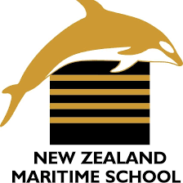

**NEW ZEALAND MARITIME SCHOOL**

**NZ Diploma in Marine Electro-technology (NZ2894)**

**(STCW 1978 A-III/6, as amended in 2010)**

**Electro-Technical Officer, Year 2 Cadets, 2020.**

**Course Code**

942.575 - AS01.

**Course Title**

Operation of Propulsion and Auxiliary Control Systems

Learning Outcomes Assessment.

**Format**

Written assignment of 400 words including diagrams and marked Competent (C) or Not-Yet Competent (NYC). Weighting = 50%.

**Due Date**

To be submitted by email to [nick.cossar@manukau.ac.nz](mailto:nick.cossar@manukau.ac.nz) for the due date of 28/06/2020.

**Tutor**

Nick Cossar

[nick.cossar@manukau.ac.nz](mailto:nick.cossar@manukau.ac.nz)

**Student Name:** Levi Dubbelman

**Student ID:** 190000929

**Date:** 20/06/2020

Outcome 1:

* Sketch a block diagram of a typical HV Diesel Electric Propulsion system.

ATTACHED HVDistribution942.575.pdf

* Describe the speed control and reversing systems of a *slow speed two stroke Diesel* main engine with fixed pitch propeller and then one with a variable pitch propeller.

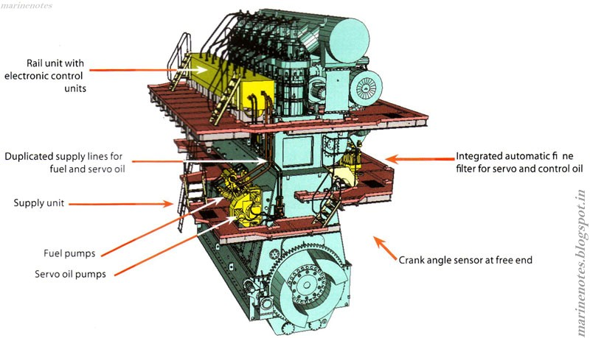

**Fixed Pitch Propeller**

Speed control for a 2-stroke slow speed diesel engine with a fixed pitch propeller is accomplished using either electronic fuel injection system on newer models, or the more traditional single injection event by controlling the % of fuel in the atomized injection through a proportional valve.

Simply, more fuel means more power and therefore more speed and less downtime between injection events.

For reversing, in smaller or medium sized engines, clutches and reverse gears can be used.

In old M.A.N engines, the reversing procedure is carried out by means of shifting the camshaft axially. For this purpose, a separate astern cam is fitted to the camshaft.

Each astern cam is fitted next to the corresponding ahead cam.

The whole camshaft can be shifted axially with the help of hydraulic cylinders fitted to the camshaft. The hydraulic oil gets pressurized and forces the piston inside the cylinder which moves the entire shaft from ahead to astern or from astern to ahead.

Locking devices and safety cut-outs are fitted to that the correct positioning of the cam is achieved.

In some engines reversing is carried by the above same procedure. Only one change is that instead of hydraulic pressure, air pressure is used for shifting the camshaft axially.

**Controllable Pitch Propeller (CPP)**

A controllable pitch propeller 2-stroke slow speed diesel engine will operate in much the same way as a fixed pitch propeller, although this engine has no need be able to run in reverse. Instead, the entire engine may constantly run in either left-handed or right-handed operation, and the blades of the propeller can be hydraulically controlled to provide thrust direction.

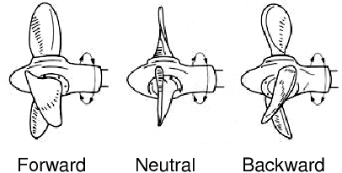

* Explain the operation of Propulsion Electric Motors (PEM) in terms of starting and variable frequency control.

A standard propulsion electric motor (PEM) will be a synchronous AC machine. Two voltages are applied to the motor, one is AC [and rectified on-rotor] or DC induced onto the rotor to provide excitation and formation of a stationary magnetic flux. The other, to the stator windings. This second, primary voltage, is generally HV, e.g. 3.3kV, 6.6kV or even 11kV, to reduce the otherwise massive size of a multiple megawatt motor.

Because these motors are synchronous, speed control is necessary. A variable frequency drive will take the ship’s supply of 50 or 60 Hz and rectify it to a DC waveform before inverting it to a variable frequency AC waveform using high power transistors known as insulated gate bipolar transistors (IGBTs).

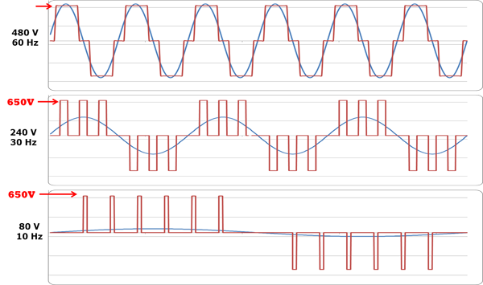

**Voltage and Current Waveforms of various frequencies provided by the VFD**

The PEM will have a fixed pitch propeller; it will rely entirely on the VFD for forward/reverse operation.

Starting of the motor is relatively simple – once there is power on the DC bus bar inside the VFD, the VFD will begin providing power in a low-frequency high-torque setting as determined by the V/F curve.

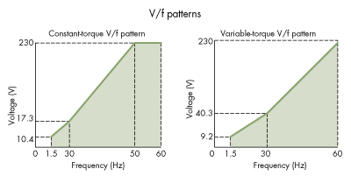

Depending on the bridge order, the VFD may be ramped up by the pilot by hand, with a built-in maximum ramp speed, or will automatically ramp up to the required speed as per the V/F curve.

This curve is intended to prevent mechanical damage from stress in a sudden change of angular velocity in the propeller, as well as to prevent electrical damage due to overcurrent as the power demand exponentially increases in relation to the torque demand, potentially even causing the synchronous motor to slip or stall if the load is too great.

* Explain the operation of a Diesel Electric (ABB) Azipod propulsion system in terms of steering and speed control.

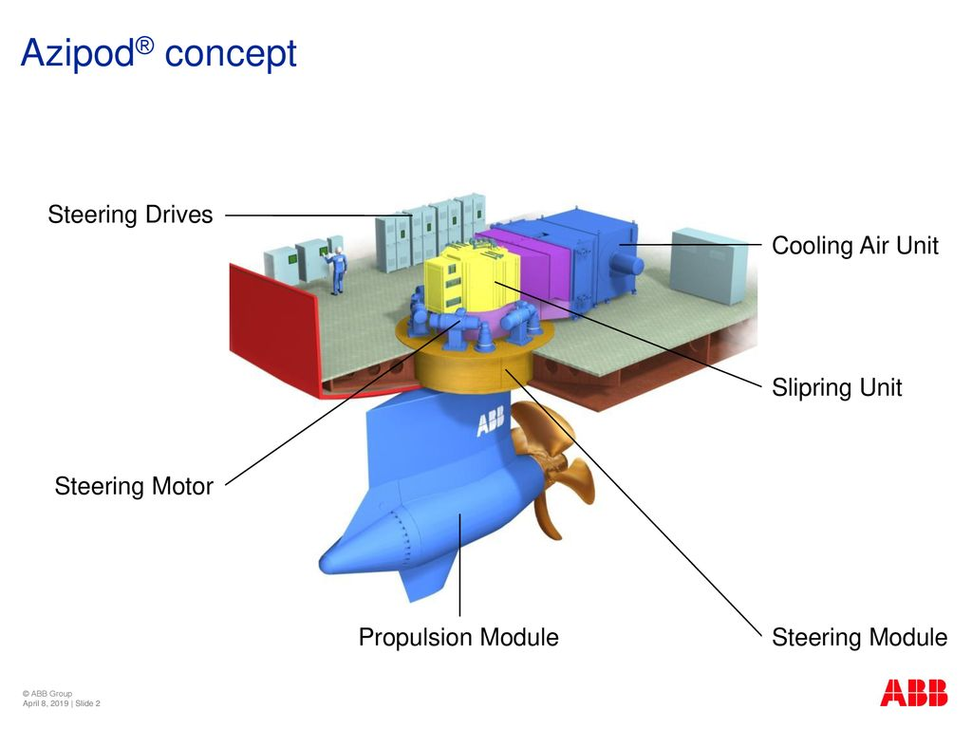

**Azimuth / Steering**

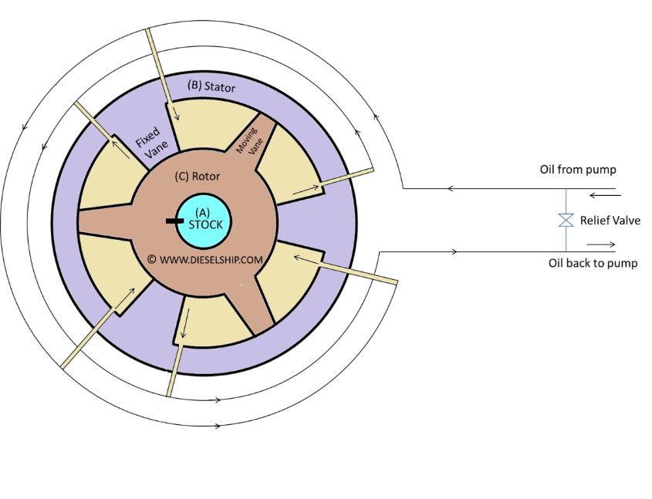

In a rotary vane steering gear, pumps keep several “vanes” under constant pressure. By releasing this pressure, the rotor may then rotate due to the differential pressure in the vanes. In turn, this steering gear will rotate the azipod housing below. The azipod housing consists of two main parts – the motor and propeller, and the azipod frame itself, which is shaped in such a way as to act as a rudder. This is typically a vessel’s primary method of steering, used in conjunction with bow/stern thrusters, and allows for the vessel to rotate on any configuration of axis with extremely tight turning radii. This configuration also allows a vessel of almost any size to require no tugs or external maneuvering assistance when coming alongside.

**Frequency Converter**

For speed control, the typical ABB Azipod will use a high voltage frequency converter. This is generally a “cycloconverter” – a variable frequency drive which uses integrated-gate commutated thyristors to “chop” the 50 or 60 Hz sinusoidal waveform into a variable frequency AC waveform of up to half of the original frequency. This is then delivered to two half-motors inside the ABB Azipod (one VFD for each half motor, driven from different switchboards, for redundancy purposes) and allows for a variable speed of up to 400 RPM at 25Hz (generally, the Azipod motors will be 6 or 8 pole asynchronous induction motors)

**Power Transmission**

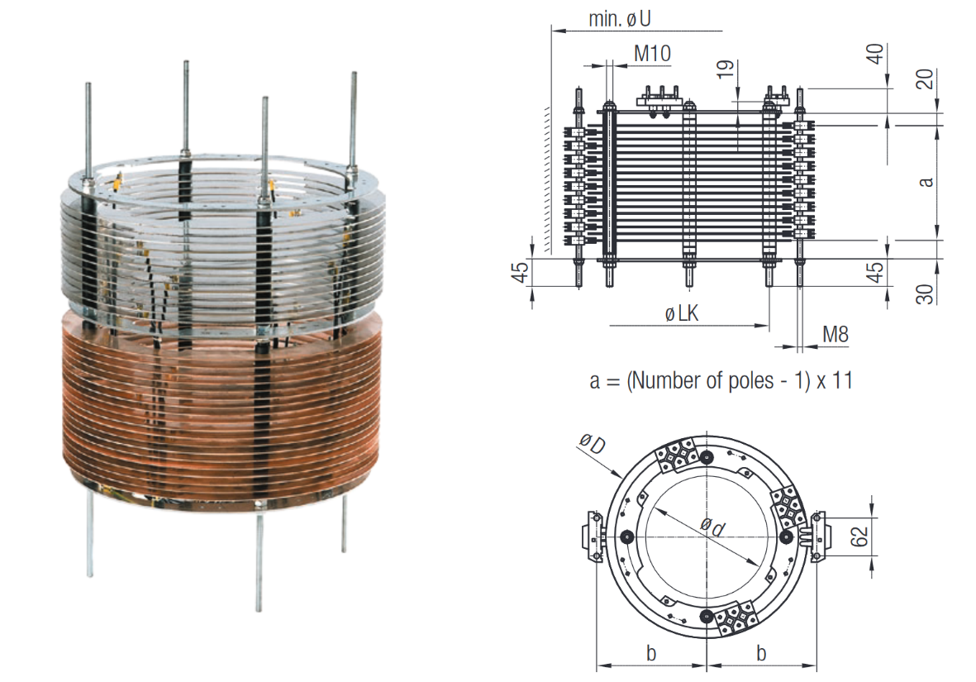

Power is delivered to the motor inside the azipod using slip rings and carbon brushes which pass HVAC (up to 2,000VAC) to the motor and azimuth alongside the thruster housing (and inbuilt rudder). While this may potentially increase the maintenance billet, as the carbon brushes will eventually wear away and require replacement, the azipod housing [and therefore the slip rings] will azimuth at a low speed and so infrequently, compared to a motor with slip-rings and commutation for rotor excitation; the only rotation which occurs is due to the steering of the vessel. Therefore, the additional maintenance requirement is a non-factor.

* Explain the operation of Bow and Stern electric thrusters in terms of motor type and starting system.

**Direct-On-Line (DOL)**

A direct-on-line electric bow/stern thruster will typically be a vertically mounted squirrel cage induction motor. This type of installation will typically only be used on ships with large amounts of available power to meet the exceptionally high inrush current which may potentially be in the order of thousands of amps, and is for this reason the most common type of starter for high voltage vessels.

The bow/stern thruster will have a variable pitch propeller for two reasons:

1. To provide speed control on the athwartships movement
2. To reduce the starting current / stress on the mechanical parts, as starting a bow/stern thruster under full load, even on a high voltage vessel, is a mechanical and electrical demand which may not be accomplished easily.

**Star Delta (Y-D) or Autotransformer**

Very similar to the DOL starter, the main purpose of using a Star-Delta or Autotransformer is to allow vessels with lower available power to use electric bow/stern thruster installations. By having a reduced voltage, at the cost of reduced starting torque, bow/stern thruster can start in 0 degree pitch and apply pitch to the propeller when running safely at full voltage.

**Variable Frequency Drive (VFD)**

A variable frequency drive in bow/stern thruster installations allows for a fixed pitch “uni-directional” propeller to be used instead of a variable pitch propeller, allowing for reduced hydraulics and maintenance, without sacrificing athwartship thrust. The tradeoff in using a VFD comes from the ramp-up/ramp-down curve which may be quite significant in a large thruster. Emergency maneuvering may be quite difficult with a VFD versus a traditional direct on-line starter. This can be offset by having multiple bow/stern thrusters working in tandem.

* Explain the operation of variable frequency drives (VFD) as used on Ships for three phase induction motors powering ships machinery and those types used for electric propulsion motors.

**AC/DC/AC (Synchroconverter)**

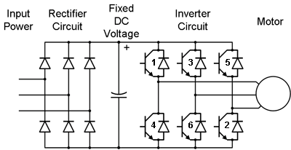

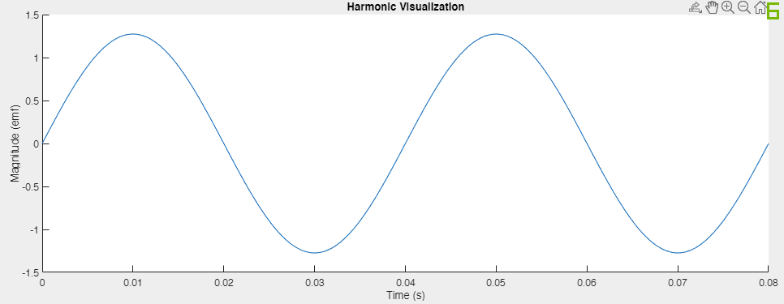

**Stage 1 – Initial Sinusoidal Waveform**

A three-phase supply is typically passed through a pair of transformers, one of which will have an earthed star point on the secondary to provide a 30° phase shift on one set of three phase. This is then delivered to a series of diodes (one diode for each phase, two banks per set of phase-shifted three phases, one for positive, one for negative, resulting in a total of four banks of diodes, or 12 diodes in total (potentially more in series with each other for higher voltages))

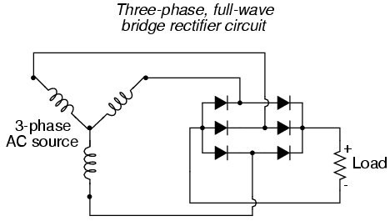

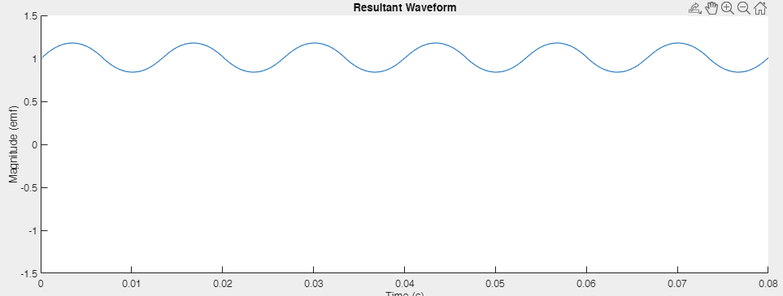

**Stage 2 – Rectified DC Waveform (Note: With the addition of the second, phase-shifted AC supply as well as inductors and capacitors for smoothing, the DC waveform will be nearly mathematically perfect. The above waveform graph is a dramatization.)**

Once rectified, the resultant DC waveform is connected to a bus bar joining the two separate diode banks. This DC voltage may be extremely high, as it is the input voltage multiplied by the square root of 3. For a 2000VAC Supply voltage, for instance, the voltage between + and – rails of the DC bus bar will be approximately 3500VDC.

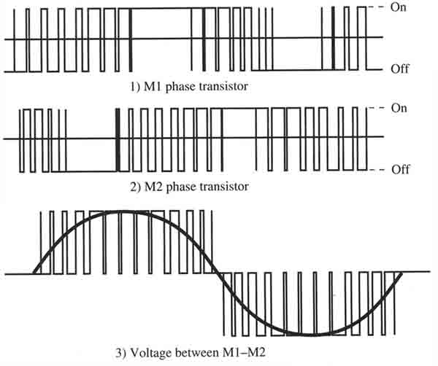

**Stage 3 – Frequency Modulated AC waveform**

Once a DC voltage is available, it is spliced into very high frequency blocks typically using insulated-gate bipolar transistors (IGBTs). By constantly modulating the width of the positive and negative DC rails, a resultant current waveform of variable frequency is generated and then passed to a synchronous machine with a fixed pitch propeller for primary propulsion.

**AC/AC (Cycloconverter)**

**Stage 1 – Initial Sinusoidal Waveform**



A three-phase supply is passed into a bank of integrated gate commutated thyristors (IGCTs). Unlike with a frequency converter with a DC link, there is no need for a transformer with an earthed star point for phase shift.

However, it should be noted the initial frequency of the supply voltage will dictate the maximum resultant frequency. The resultant frequency may never exceed approximately half of the initial supply frequency. For instance, a supply frequency of 50 Hz will produce a maximum useable frequency of 25Hz. This is generally not an issue, however, as prime movers of a vessel will have relatively low angular velocity requirements (generally between 0-400 RPM, depending on vessel size and intended speed.)

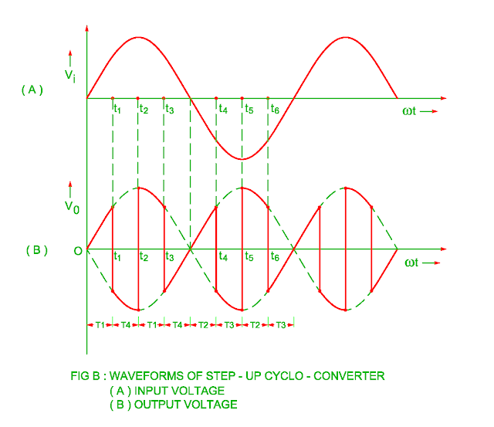

**Stage 2 – “Chopped” AC waveform**

The above graph represents the highest possible frequency waveform produced by an IGCT of exactly half the supply waveform.

An integrated-gate commutated thyristor will alter the resultant frequency by modifying the intended firing angle.

* Give an overview of a typical power management system for a Diesel Electric ship (e.g. Kongsberg control).

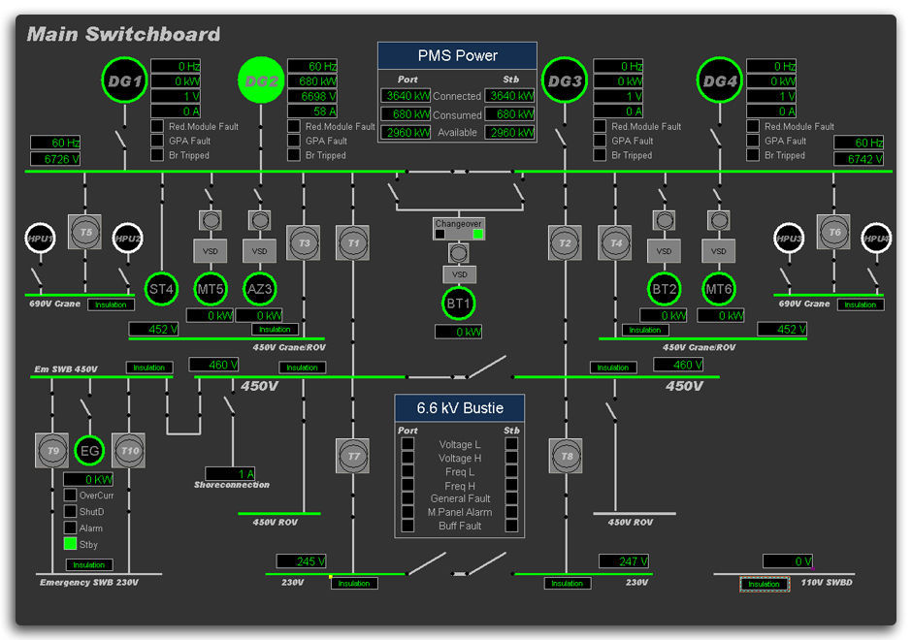

The main task of the PMS system is to ensure a balance between power consumption and power production, thus keeping the electrical network as stable as possible. In practice this is done by controlling the electrical power production resources as well as controlling the usage of large consumers.

For propulsion, which, on a diesel-electric vessel, is typically the primary consumer of generated electrical power, an advanced power management system will communicate with sensors to determine various factors, such as:

–  Draft – changes in the hydrodynamic drag due to the changes in the vessel draft.  
–  Squatting – additional power required in the shallow waters, where the power required to displace the water is increased.  
–  Rudder usage – additional drag due to the rudder angle of attack.  
–  Stabilizer usage – additional drag due to the stabilizer fin angles of attack.  
–  Propelling effort – power required to overcome both the hydrodynamic resistance of the vessel and vessel inertia.  
– Floating position – additional power required for moving the vessel due to suboptimal trimming and listing of the vessel, that is, to overcome the impact of the increased hull resistance and inefficient orientation of the propulsion water flow field.  
– Sea state – additional power required to overcome the impact of the rough seas such as high waves slamming the vessel.  
– Other factors that contribute to unidentifiable phenomena such as the hydrodynamics of the media itself.

There are many ways to produce electrical power on ships. In diesel-electric vessels, the most common means nowadays is to have, for example, four or six diesel generators, two or four of which can be of different sizes.

Energy Storage Systems a relatively recent addition to a power management system’s duty. A good power management system is designed to optimize operation of the power plant by considering the current and future power demand and the operation mode and will factor in the available energy storage to accomplish this.

(400 words and diagrams where necessary)